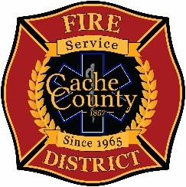
CACHE COUNTY FIRE DISTRICT
BOARD OF TRUSTEES
Kathryn Beus – Board Chair George Daines – Trustee
David Erickson – Trustee Steve Miller – Trustee
Lyndsay Peterson – Trustee Aaron Rudie – Trustee
Larry Jacobsen - Trustee

BOARD OF TRUSTEES WORKSHOP MINUTES
April 6, 2026
4:00pm
The Cache County Fire District Board will meet Monday, April 6, 2026, commencing at 4:00 p.m. in the Cache County Administration Building, Multipurpose Room Level 1, 179 North Main Logan, Utah 84321.
- CALL TO ORDER:
- In the absence of Chair Beus, Trustee Peterson called the meeting to order.

- WORKSHOP DISCUSSION
-Execute Daines presented his proposal for Alternatives for Fire District. There were questions and discussions among those who attended the meeting. There is an audio recording of the workshop posted,

https://www.cachecounty.gov/fire/firemeetings/audio.html?mtg_id=8758

- ADJOURN
-Execute Daines adjourned meeting @ 5:15 PM

In compliance with the Americans with Disabilities Act, individuals needing special accommodations (including auxiliary communicative aids and services) during this meeting should notify Janeen Allen, at 755-1850 at least three working days prior to the meeting.

